

Practices for Secure Software Report

Table of Contents
Document Revision History 3
Client 3
Instructions 3
Developer 4
1. Algorithm Cipher 4
2. Certificate Generation 4
3. Deploy Cipher 5
4. Secure Communications 5
5. Secondary Testing 5
6. Functional Testing 5
7. Summary 6
8. Industry Standard Best Practices 6

Document Revision History

Version | Date | Author | Comments
1.0 | 10-16-2026 | Joseph Charitable Jr

Client



Instructions

Submit this completed practices for secure software report. Replace the bracketed text with the relevant information. You must document your process for writing secure communications and refactoring code that complies with software security testing protocols.

- Respond to the steps outlined below and include your findings.
- Respond using your own words. You may also choose to include images or supporting materials. If you include them, make certain to insert them in all the relevant locations in the document.
- Refer to the Project Two Guidelines and Rubric for more detailed instructions about each section of the template.

Developer
Joseph Charitable Jr

Algorithm Cipher

For Artemis Financial, I recommend using the SHA-256 cryptographic hash algorithm for the checksum functionality. SHA-256 is part of the Secure Hash Algorithm 2 (SHA-2) family and produces a fixed-length 256-bit hash value from the input data. The hash can be used to verify that information has not been changed while being transferred. If the original data and the received data produce the same SHA-256 hash, the data can be considered unchanged. If the hashes are different, the data has been modified or corrupted.
SHA-256 is appropriate for this application because the purpose of the checksum is to provide data integrity rather than to encrypt the data so that it can be read only by authorized users. Hashing is a one-way process, meaning that the original information should not be able to be reconstructed from the hash value. The 256-bit output provides a large number of possible hash values, making it computationally impractical to intentionally create two different inputs with the same hash.
Cryptographic systems can use random numbers when generating keys, initialization values, salts, or other security-related values. Randomness is important because predictable values can make security mechanisms easier to attack. SHA-256 itself does not use a symmetric or asymmetric encryption key because it is a hashing algorithm rather than an encryption algorithm. Symmetric encryption uses the same secret key to encrypt and decrypt information, while asymmetric encryption uses a public and private key pair. Asymmetric cryptography is commonly used with digital certificates and secure communications, while hashing is used primarily for integrity verification.
Encryption technology has developed significantly over time as older algorithms have become vulnerable to increasingly sophisticated attacks. Older hashing algorithms such as MD5 and SHA-1 are no longer recommended for new security implementations because weaknesses have been identified in their collision resistance. SHA-256 remains a widely used member of the SHA-2 family for cryptographic hashing and provides a stronger option for the checksum requirement in the Artemis Financial application.
For this project, I will use SHA-256 to create a checksum for the application's data and use HTTPS/TLS to protect communications between the client and server. These mechanisms provide separate layers of security: SHA-256 helps verify data integrity, while HTTPS/TLS helps protect data while it is being transmitted.

Certificate Generation
Insert a screenshot below of the CER file.

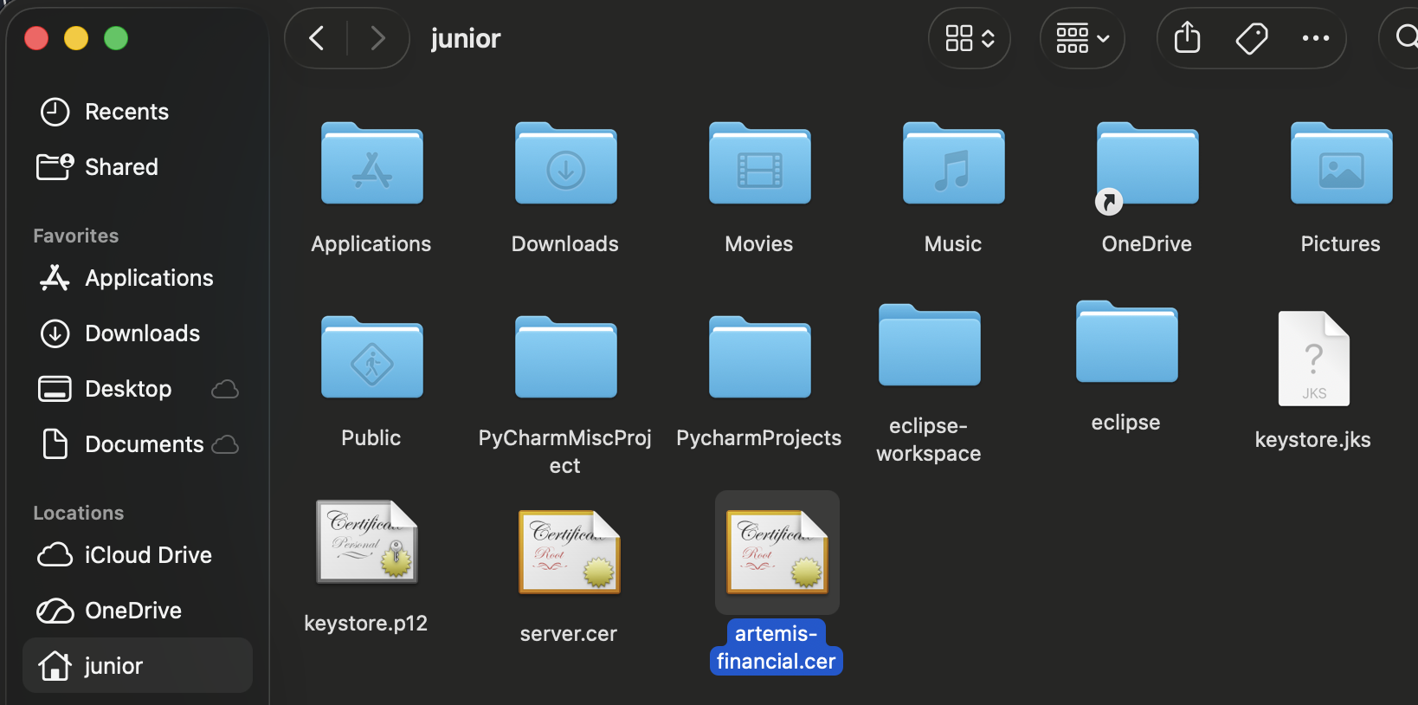

Deploy Cipher
Insert a screenshot below of the checksum verification.

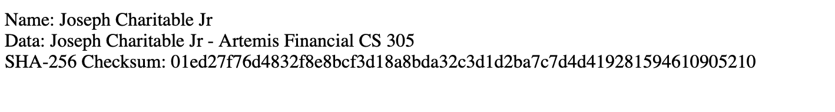

Secure Communications
Insert a screenshot below of the web browser that shows a secure webpage.

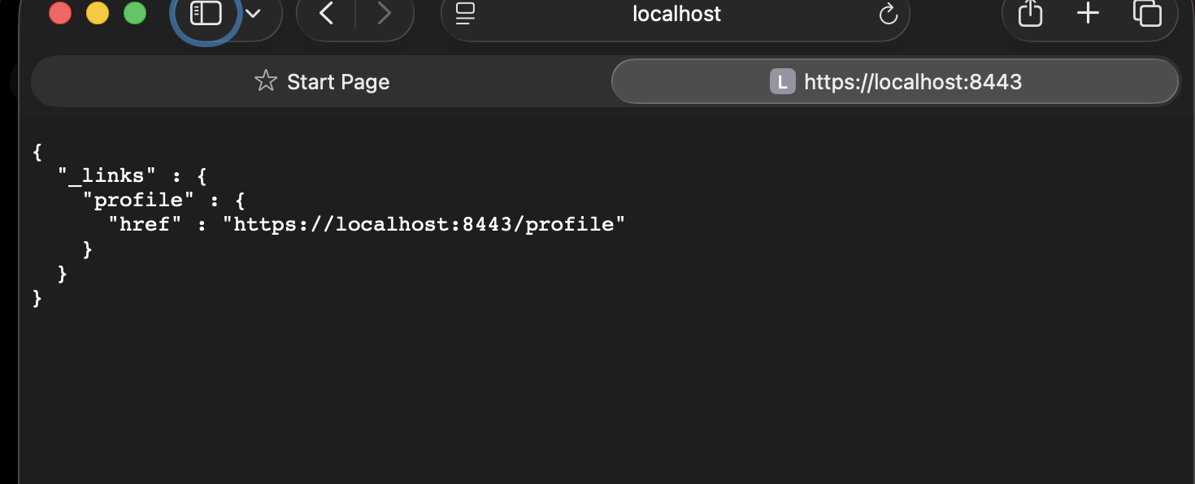

Secondary Testing
Insert screenshots below of the refactored code executed without errors and the dependency-check report.

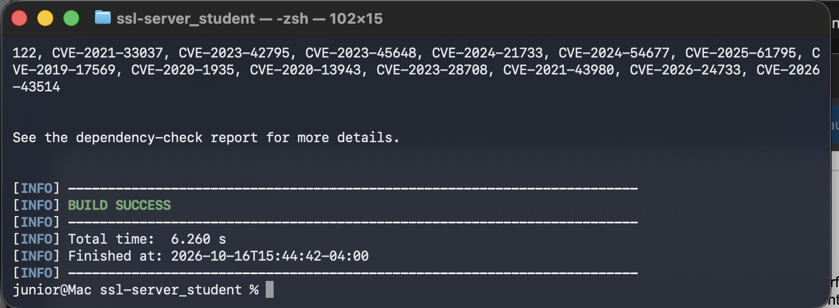
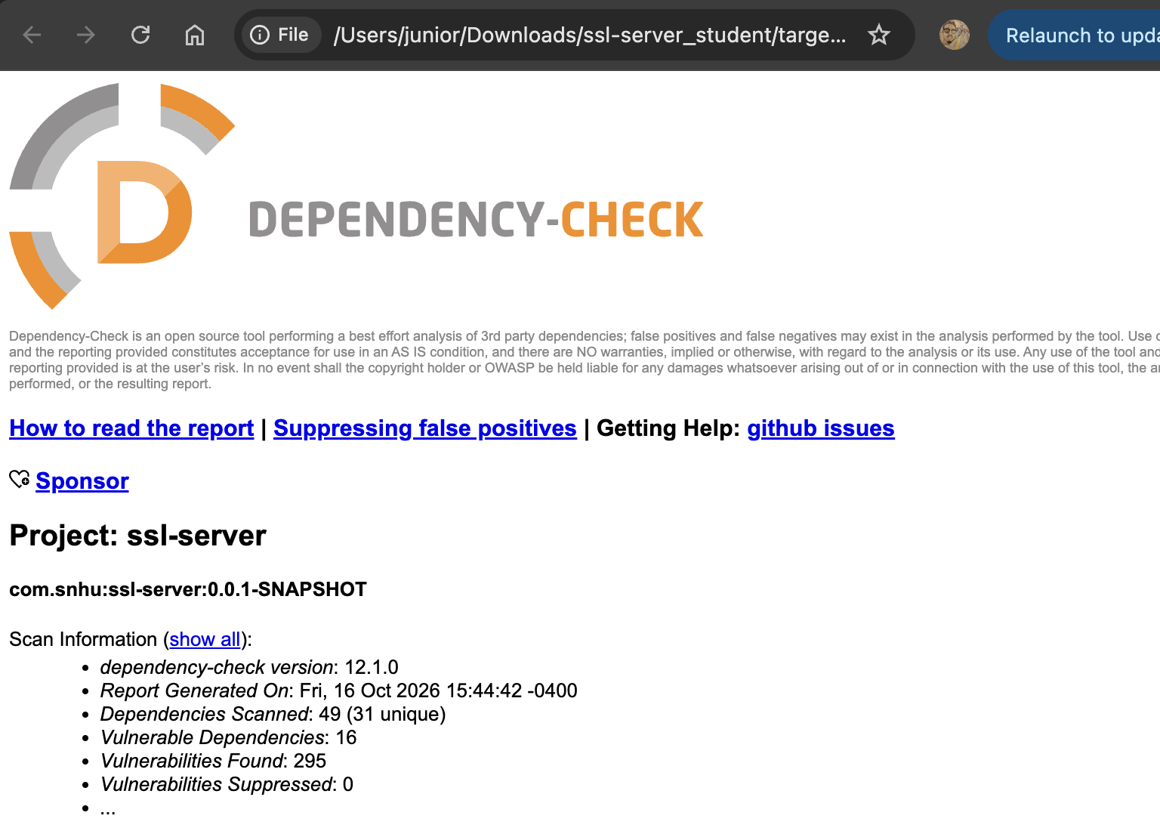

Functional Testing

Insert a screenshot below of the refactored code executed without errors.

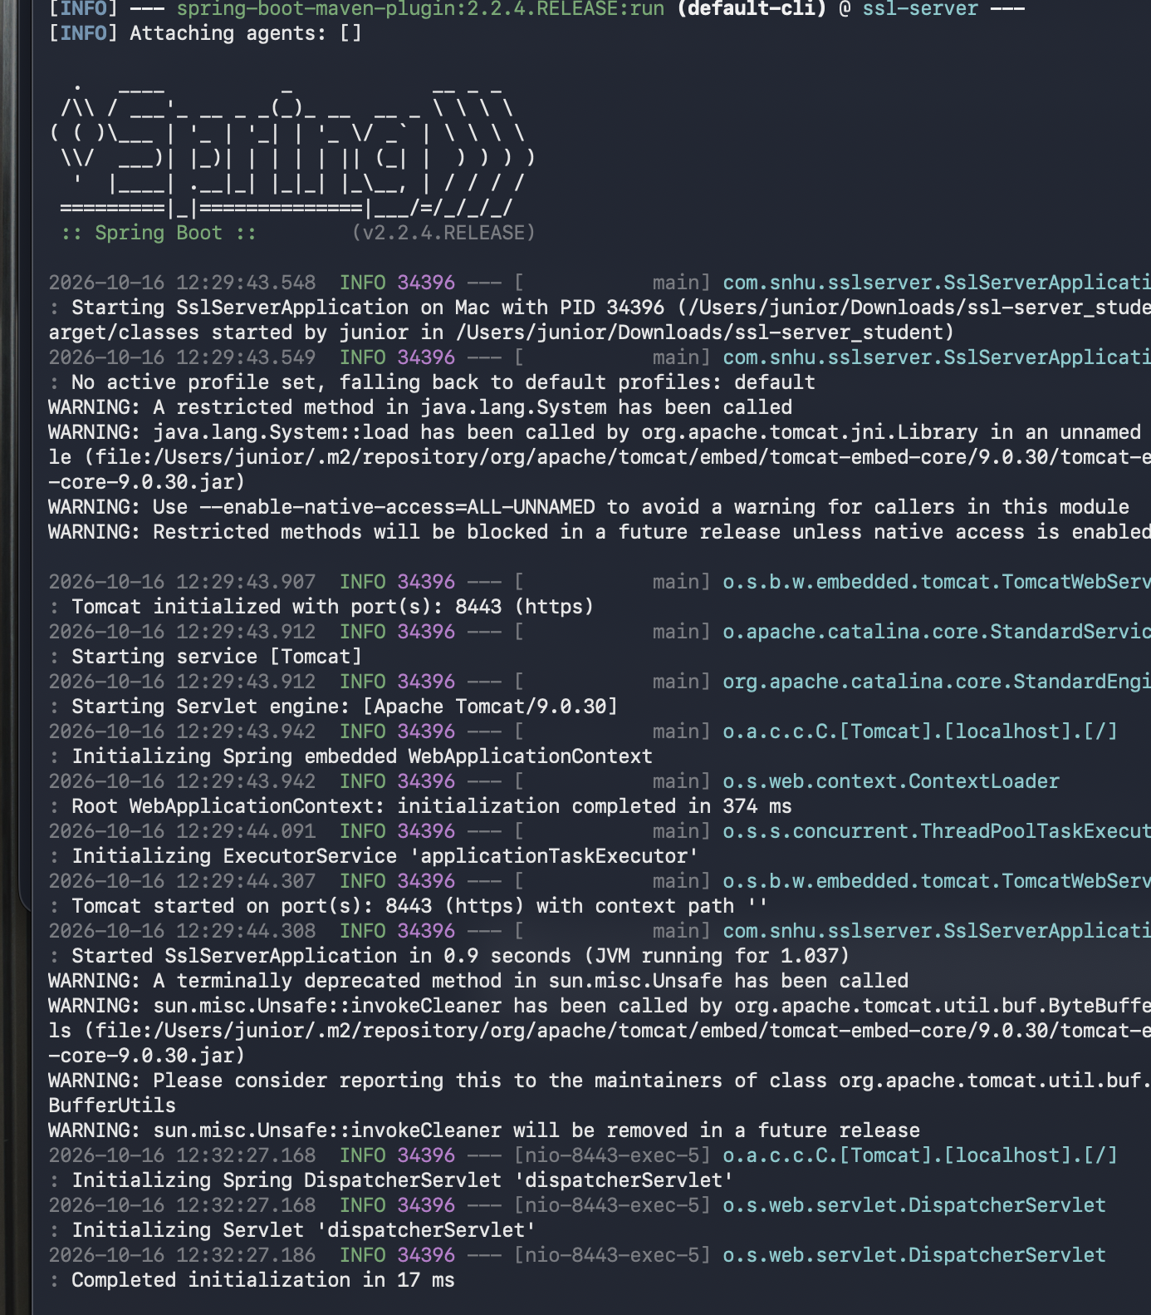

Summary

Summary
The Artemis Financial application was refactored to improve the security of communications, protect the integrity of transmitted data, and support secure software testing practices. A SHA 256 cryptographic hash was implemented to provide a checksum that can be used to verify that data has not been altered during transmission. The application was also configured to use HTTPS through a self-signed certificate, providing secure communication between the client and server.
The refactoring addressed security concerns related to protecting data during communication and verifying data integrity. The application was tested after the security changes were implemented to make sure the new functionality operated correctly. Maven validation completed successfully, and the application was successfully started using HTTPS on port 8443. The checksum functionality was also tested using a unique data string.
Security was added in multiple layers rather than relying on a single security control. SHA-256 provides a layer for data integrity, while HTTPS/TLS provides a layer for protecting information while it is transmitted. The self-signed certificate supports the HTTPS implementation, and Dependency-Check provides an additional layer of security testing by examining the application's third-party dependencies for known vulnerabilities. Functional testing and manual code review provided another layer by checking the refactored application for syntactical, logical, and security issues.
The refactoring and testing process followed the vulnerability assessment approach by identifying security concerns, implementing appropriate security controls, and testing the application after the changes were made. The successful application startup and Dependency-Check scan provided evidence that the refactored application could be built and executed while incorporating the new security mechanisms. These layers of security help Artemis Financial protect its customers' financial information while maintaining the integrity and security of its web application.

Industry Standard Best Practices

Industry Standard Best Practices
Industry standard secure coding practices were applied throughout the refactoring of the Artemis Financial application. The application uses SHA-256 for checksum verification so that data integrity can be checked without storing or transmitting the original data as part of the verification process. HTTPS/TLS was also implemented to protect information while it is being transmitted between the client and server. A self-signed certificate was generated using Java Keytool to support the secure HTTPS configuration.
I also used security testing practices to maintain the application's existing security and identify potential vulnerabilities. The Dependency-Check tool was used to scan the application's third-party dependencies for known vulnerabilities. Maven validation and functional testing were performed after the changes to verify that the application continued to build and run correctly. Manual review of the refactored code was also used to identify potential syntactical, logical, and security issues.
Applying secure coding best practices is valuable to Global Rain and Artemis Financial because financial applications handle sensitive customer and financial information. Using multiple security controls helps reduce the likelihood that a single security weakness will compromise the application. Secure communications help protect information in transit, checksum verification helps maintain data integrity, and dependency and functional testing help identify security and software defects. Following these practices also supports the company's mission that “Security is everyone’s responsibility” by incorporating security throughout the software development and testing process.
Maintaining these practices throughout future development can help Artemis Financial reduce security risks, protect customer information, maintain customer trust, and support the overall reliability of its software application.

